DIS-Wounaan & Embera Indian basket-Panama

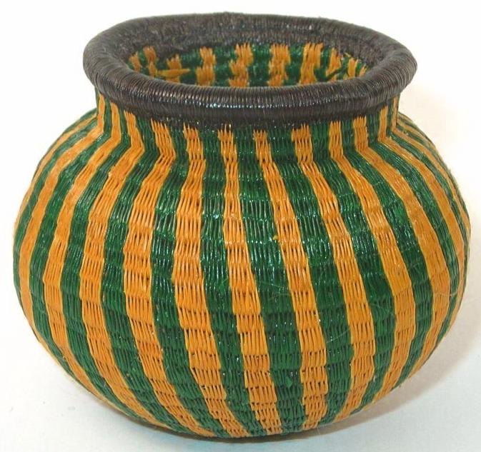

Wounaan & Embera Indian baskets and masks are woven from the first growth of the black chunga palm. The dies are mostly made from natural plants found in the jungles of Panama. The Wounaan & Embera baskets are some of the most beautiful basketry portraying plants - animals - fish - flowers - insects and geometric patterns. This piece measures approximately 2.5 inches tall by 3 inches wide and 9 inches in circumference. Handcrafted by the Wounaan & Embera Indians in the Darien Rainforest of Panama.